**SOFTWARE ENGINEERING LAB TASK 3**

**11-12-2024**

**HU22CSEN0100287**

**SAI GANESH ESWARAPRASAD**

Implement weather modelling using the quadratic solution in stages: hard coding variables keyboard input, read from a file, for a single set of input, multiple sets of inputs. save all versions, debug, fix problems, create a GitHub account**.**

**Aim:**

To model temperature changes over time using the quadratic equation:  
**Temperature=a×(time)^2+b×(time)+c**

This program will demonstrate multiple stages of input processing and ensure the solution is debugged and saved to GitHub.

**Steps for Implementation**

**1. Hardcoding Variables**

* Use predefined values for coefficients a, b, and c.
* This stage uses fixed values for the coefficients of the quadratic equation
* This step serves as a proof of concept to test the formula and ensure the program produces correct results before introducing dynamic inputs.

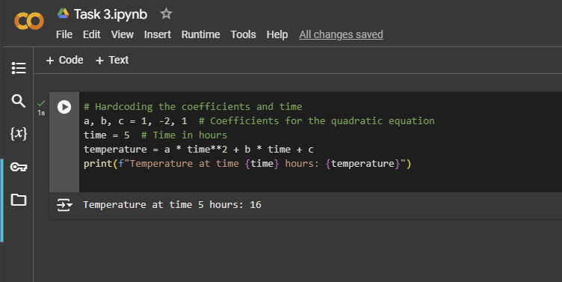

**2. Accepting Variables via Keyboard Input**

Here, the program dynamically accepts inputs from the user using Python’s input() function. This makes the program interactive and flexible.

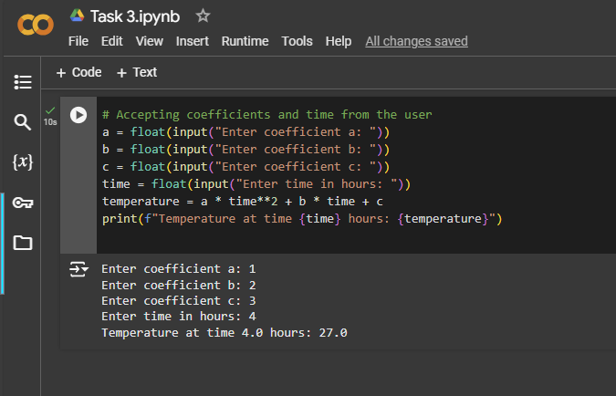

Create respective files and upload to drive 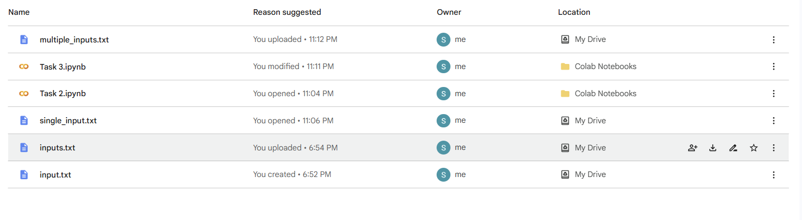

**3. Reading Variables from a File**

**(a) Single Set of Inputs**

In this step, the coefficients a, b, c, and time are read from a file that contains a single line of data.

Input File (single_input.txt): 1, -2, 1, 5

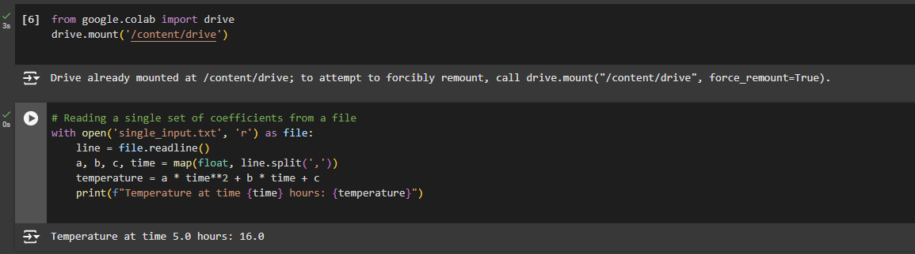

**(b) Multiple Sets of Inputs**

This step handles a file with multiple lines, where each line represents a set of coefficients and time values.

**Input File Example (multiple_inputs.txt):**

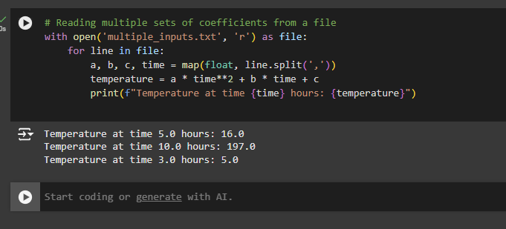

**4. Debugging and Error Handling**

Add checks to prevent common runtime errors such as missing files or incorrect input formats.

**File Not Found Error:**

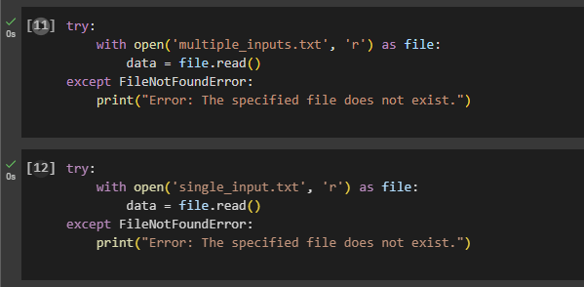

**Invalid Input Format Error:**

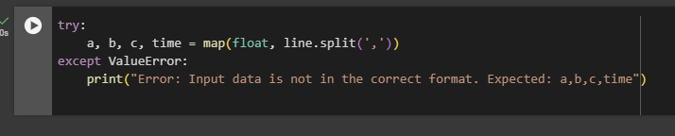

**5. Saving Versions**

After each stage, save the implementation in a separate code cell or file for record-keeping.

**6. Pushing the Project to GitHub**

Step 1: Click on file and select option “Save a copy in GitHub”

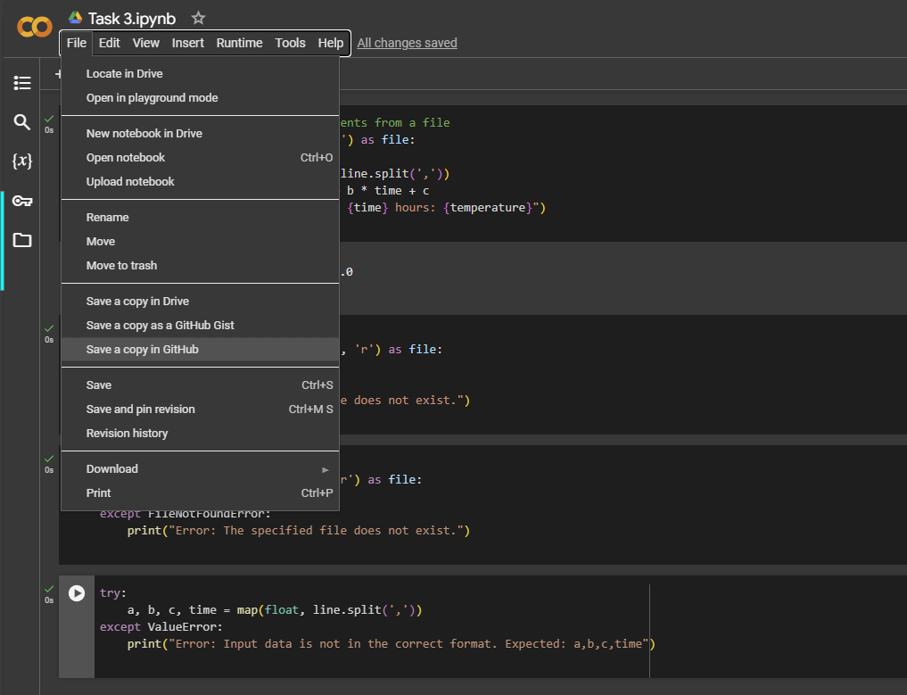

Step 2: Authorize Collaboratory

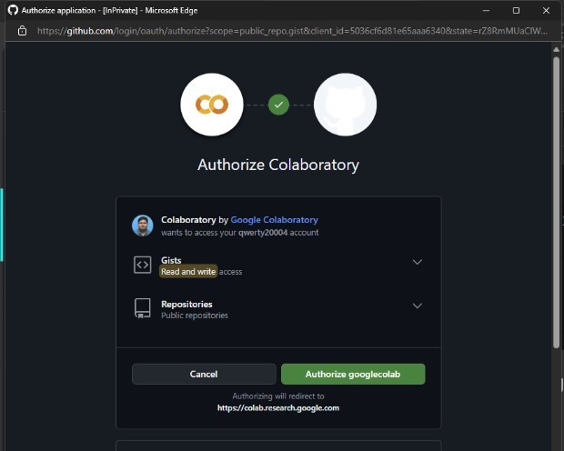

Step 3: Click on ‘OK’ for copying to GitHub.

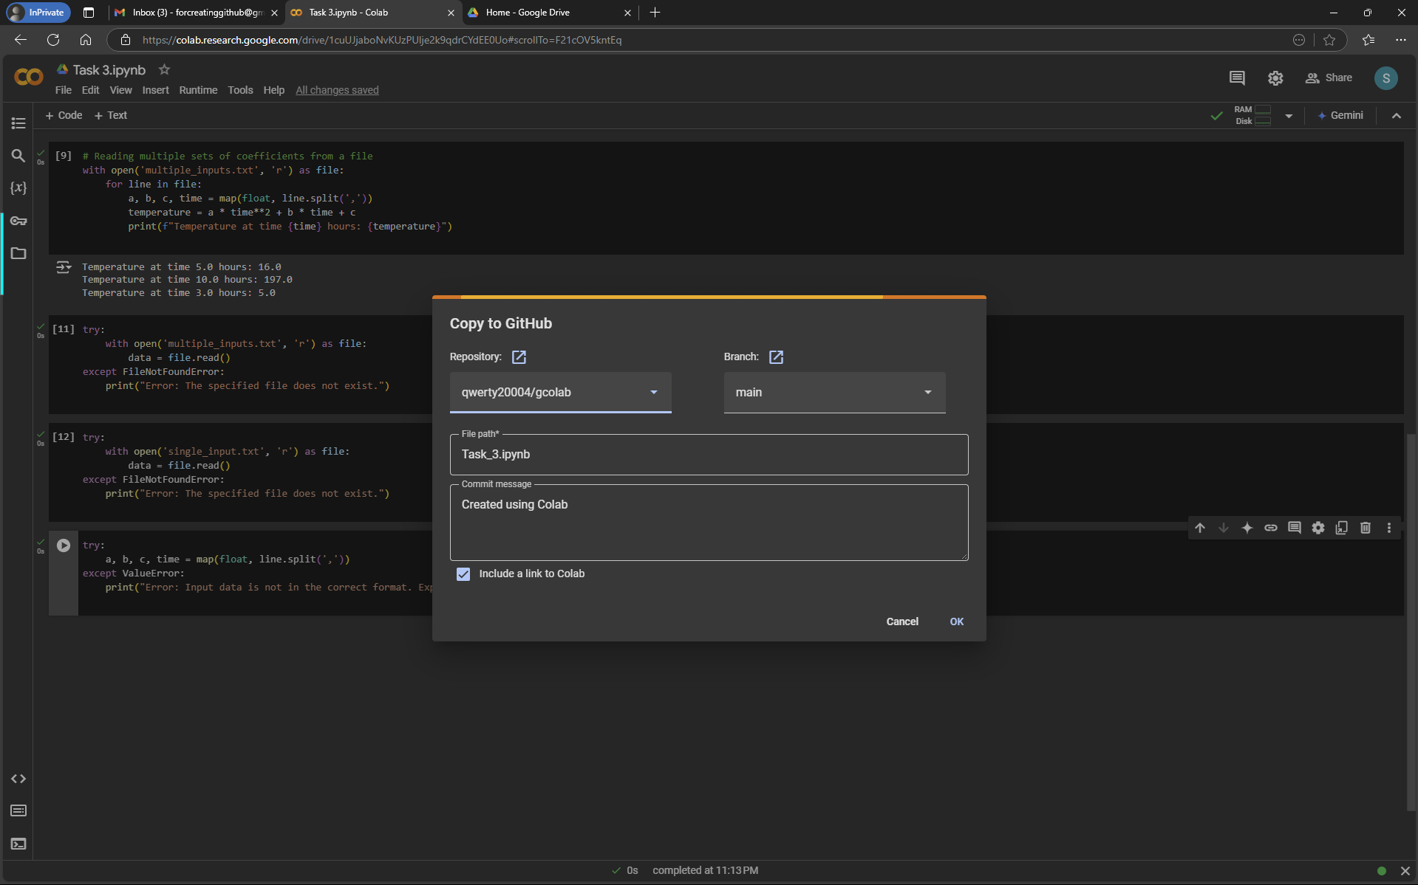

Step 4: Pushed into GitHub

